Problem No: 2302056_50

Problem Name: Write a C program to read an array of length 6, change the first element by the last, the second element by the fifth and the third element by the fourth. Print the elements of the modified array.

Input:

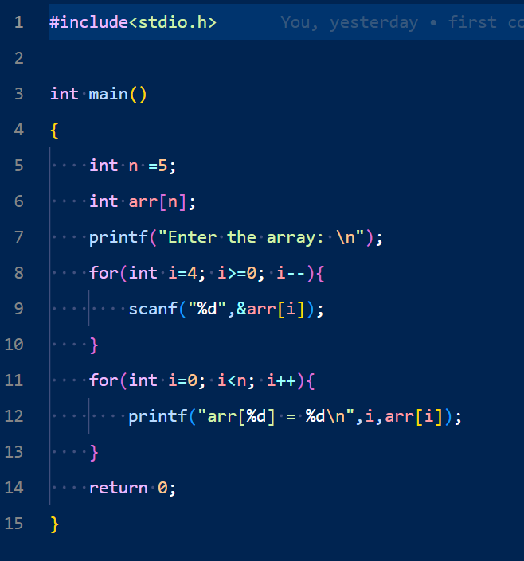 Output:

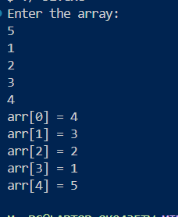

Problem No: 2302056_52

Problem Name: Write a C program to read an array of length 6 and find the smallest element and its position.

Input:

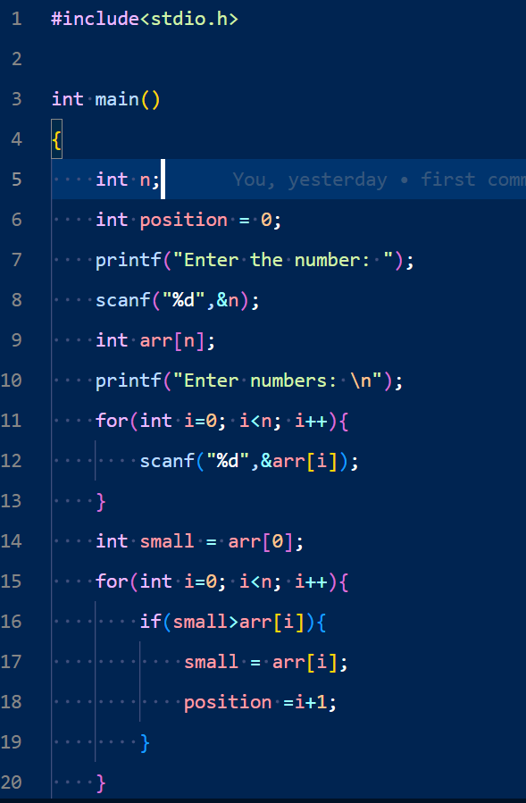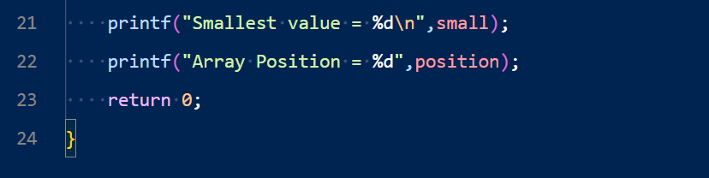Output:

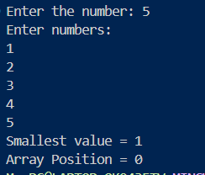

Problem No: 2302056_52

Problem Name: Write a C program that accepts the principle, rate of interest, and time and calculates simple interest.

Input:

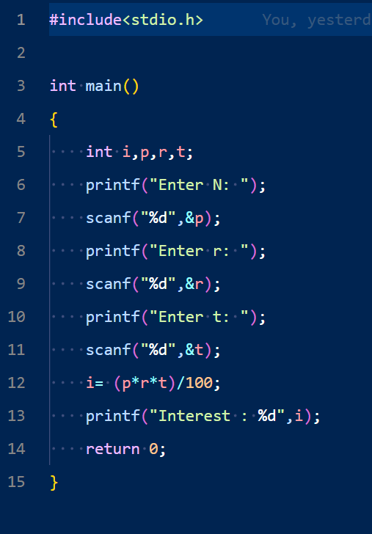

Outptu:

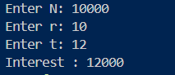

Problem No: 2302056_54

Problem Name: Write a C program that accepts a distance in centimeters and prints the corresponding value in inches.

Input:

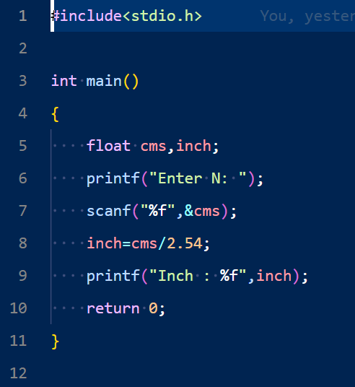

Output:



Problem No: 2302056_55

Problem Name: Write a C program that swaps two numbers without using a third variable.

Input:

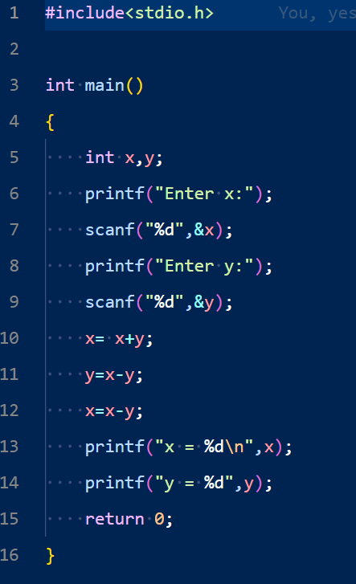

Output:

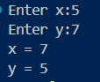

Problem No: 2302056_56

Problem Name: Write a C program to shift given data by two bits to the left.

Input:

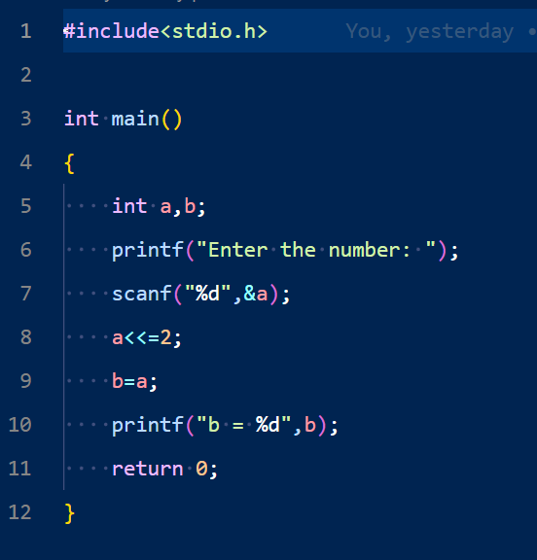

Output:



Problem No: 2302056_57

Problem Name: Write a C program to reverse and print a given number.

Input:

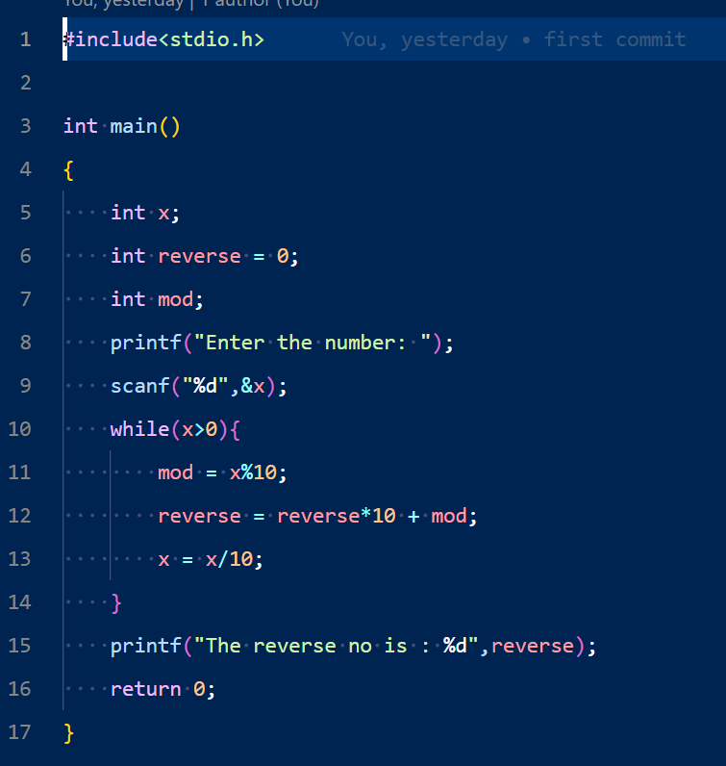

Output:



Problem No: 2302056_58

Problem Name: Write a C program that accepts 4 real numbers from the keyboard and prints out the difference between the maximum and minimum values of these four numbers.

Input:

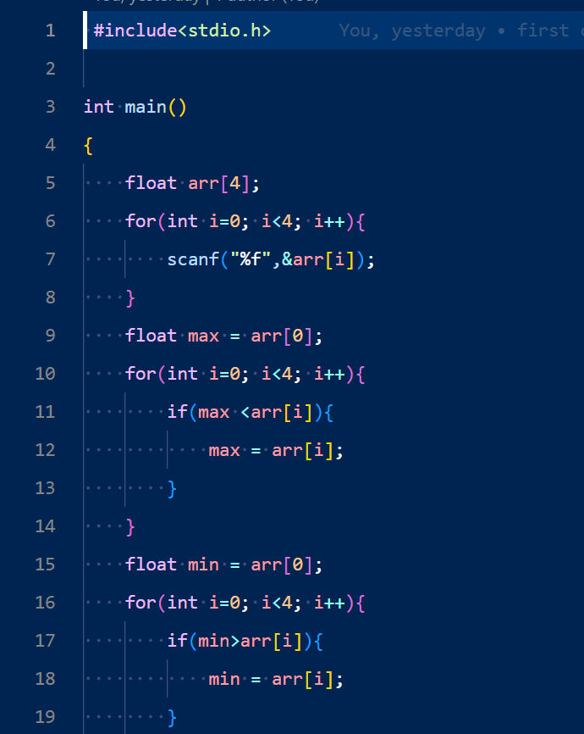

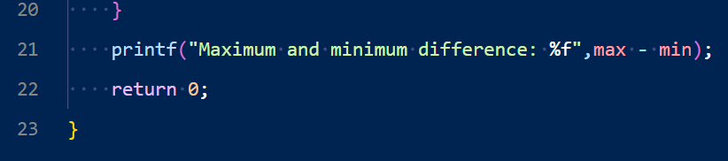

Output:



Problem No: 2302056_59

Problem Name: Write a C program to display the sum of series 1 + 1/2 + 1/3 + ………. + 1/n.

Input:

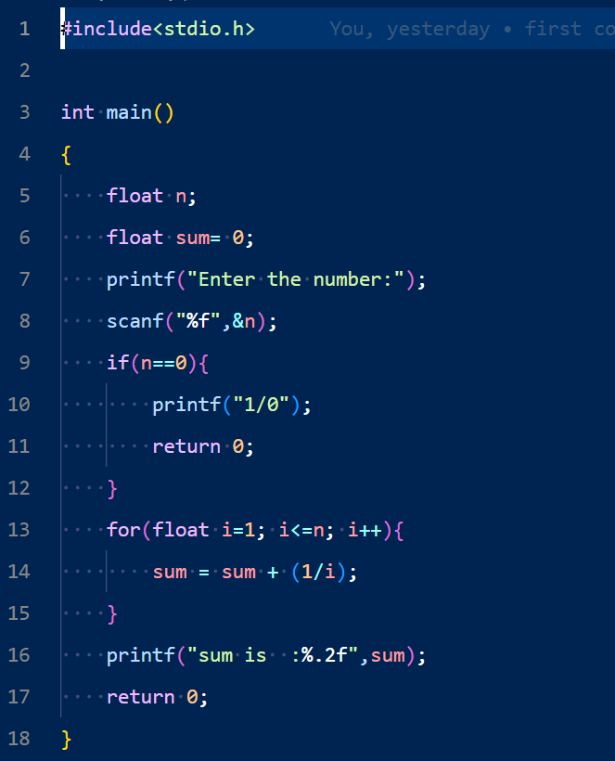

Output:



Problem No: 2302056_60

Problem Name: Write a C program to create enumerated data types for 7 days and display their values in integer constants. Write a C program to create enumerated data types for 7 days and display their values in integer constants.

Input:

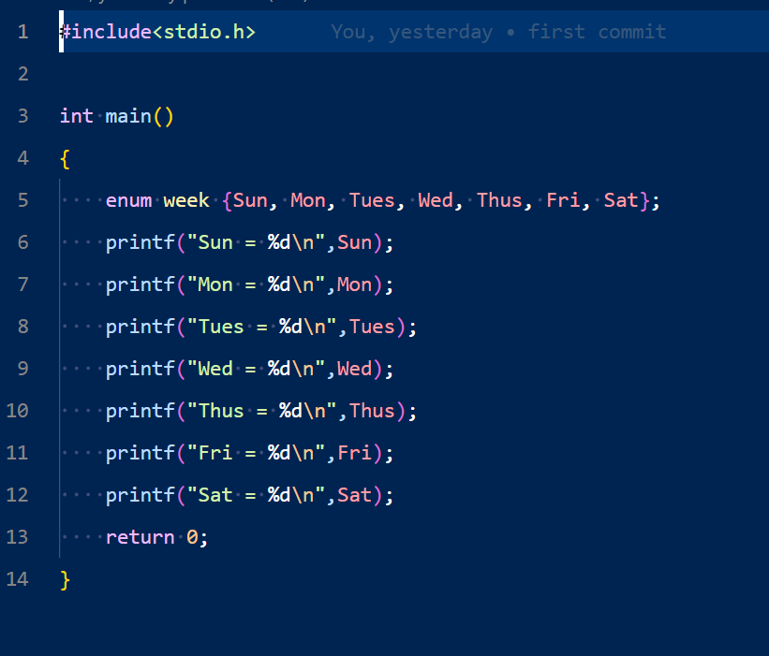

Output:

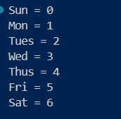

Problem No: 2302056_61

Problem Name: Write a C program that accepts a real number x and prints out the corresponding value of sin(1/x) using 4-decimal places.

Input:

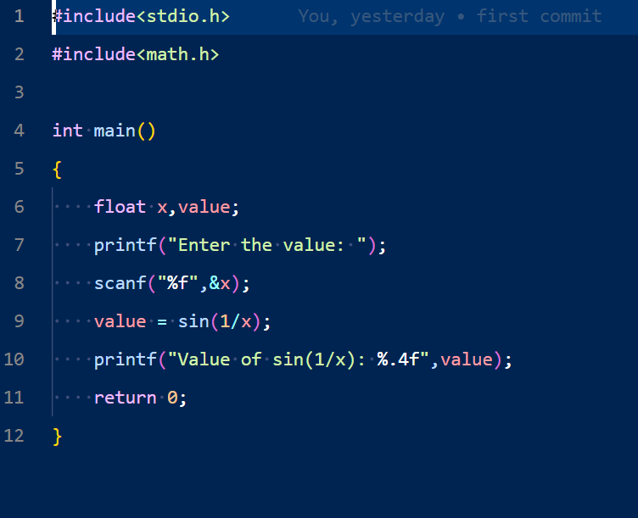

Output:

 

Problem No: 2302056_62

Problem Name: Write a C program that accepts a positive integer less than 500 and prints out the sum of the digits of this number. Write a C program that accepts a positive integer less than 500 and prints out the sum of the digits of this number.

Input:

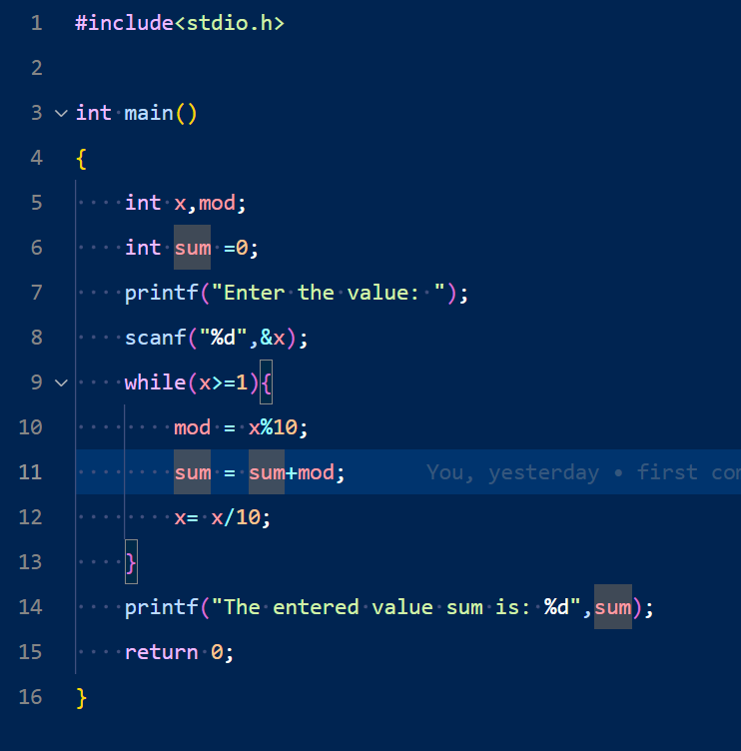 

Ouptut:



Problem No: 2302056_64

Problem Name: Write a C program that accepts integers from the user until a zero or a negative number, displays the number of positive values, the minimum value, the maximum value, and the average value.

Input:

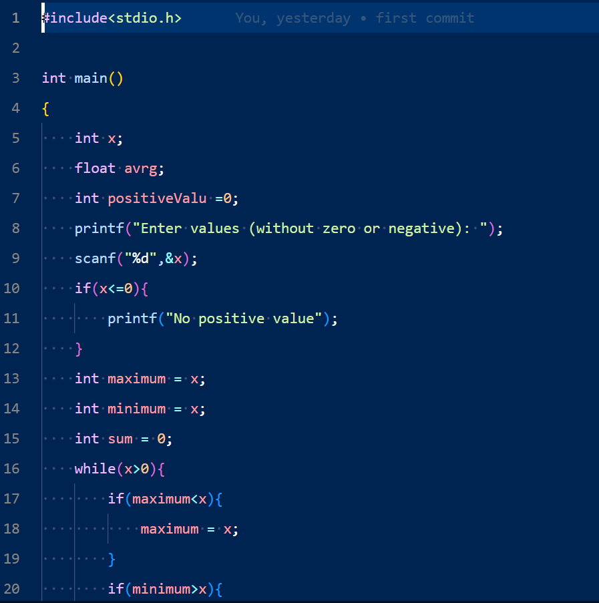 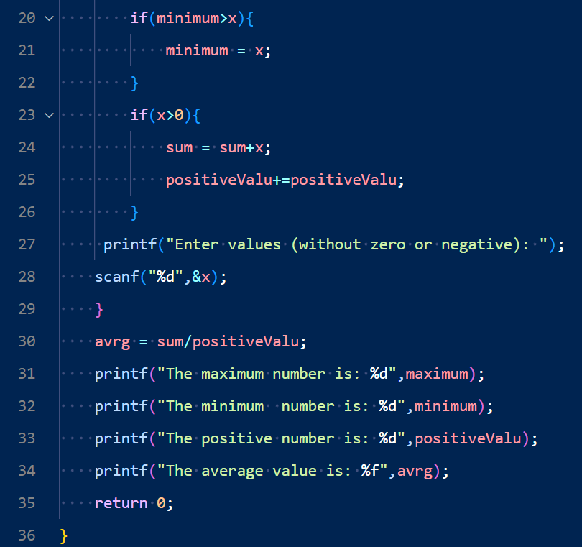

Output:

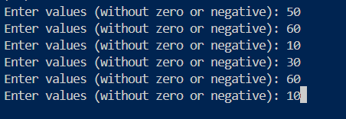

Problem No: 2302056_68

Problem Name: Write a C program that prints the powers of 2 table for the powers 0 to 10, both positive and negative.

Input:

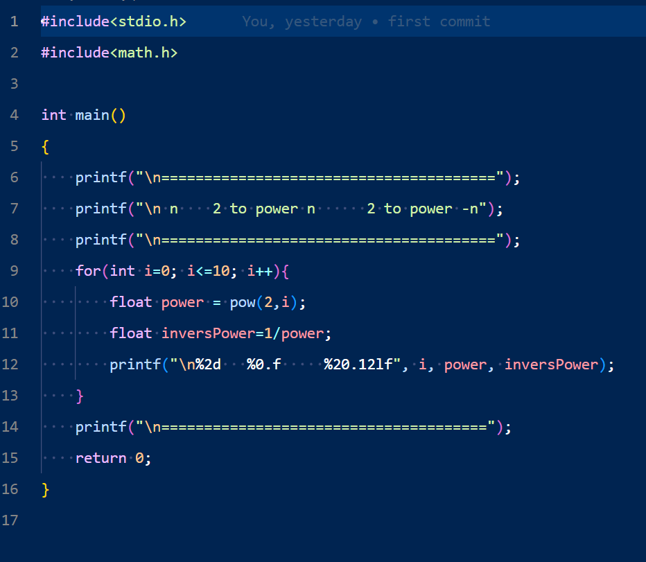

Output:

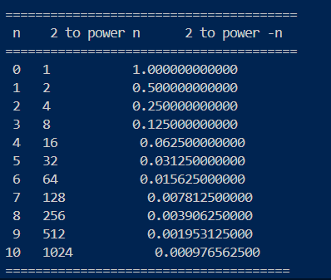

Problem No: 2302056_70

Problem Name: Write a C program to print the alphabet set in decimal and character form.

Input:

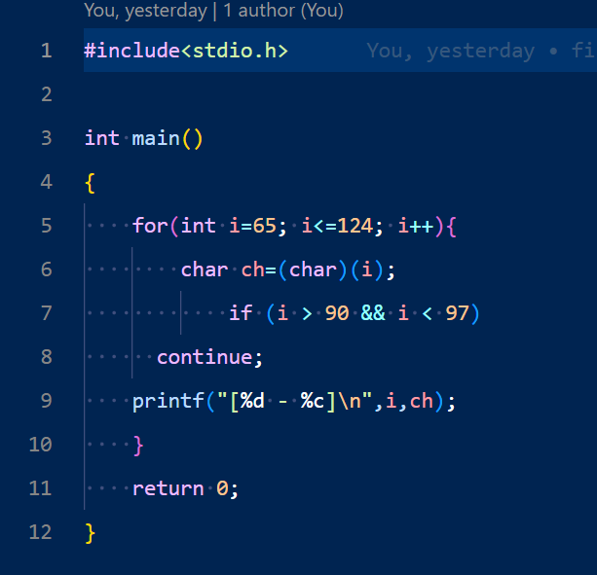

Output:

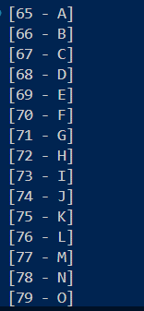

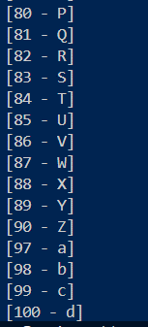

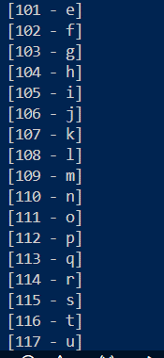

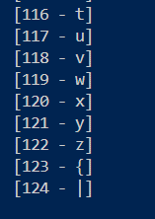

Problem No: 2302056_72

Problem Name: Write a C program to remove any negative sign in front of a number.

Input:

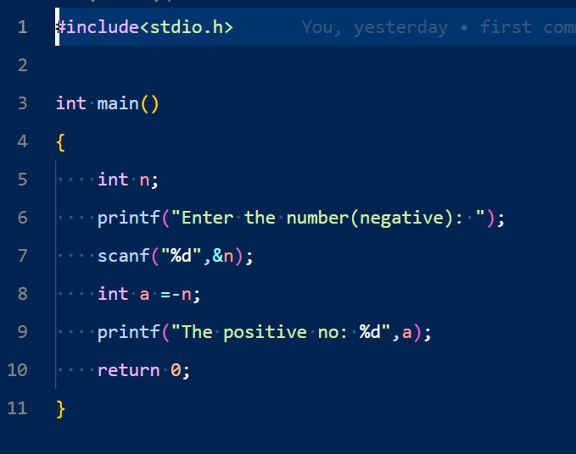

Output:



Problem No: 2302056_73

Problem Name: Write a C program that reads two integers and checks whether the first integer is a multiple of the second integer.

Input:

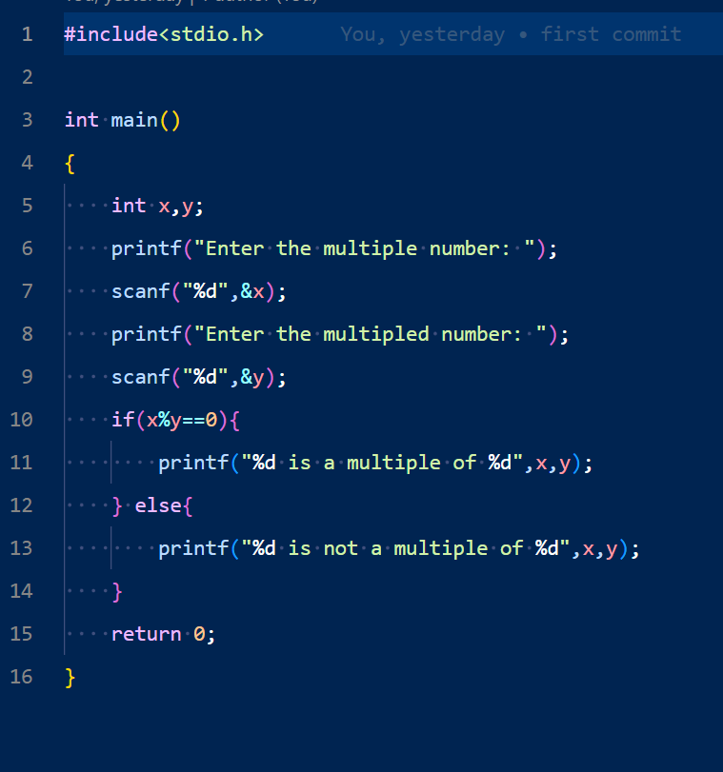

Output:

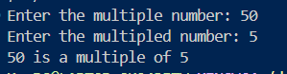

Problem No: 2302056_74

Problem Name: Write a C program to display the integer equivalents of letters (a-z, A-Z).

Input:

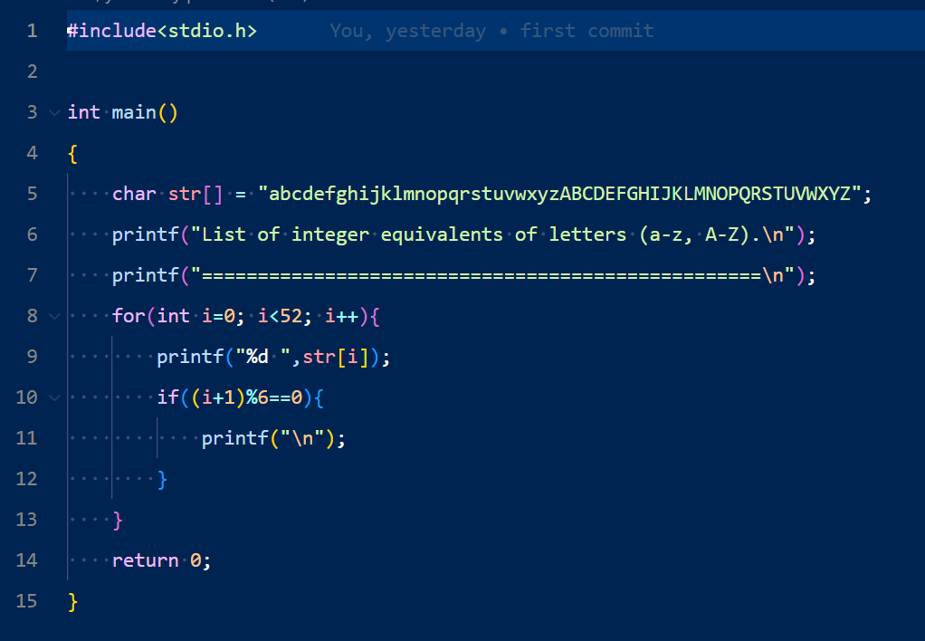

Output:

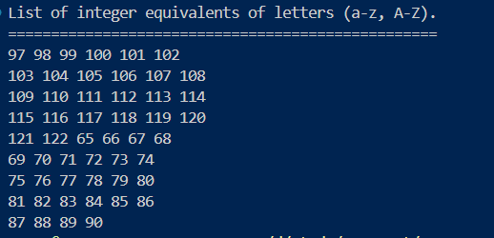

Problem No: 2302056_75

Problem Name: Write a C program that accepts a seven-digit number, separates the number into its individual digits, and prints the digits separated from one another by two spaces each.

Input:

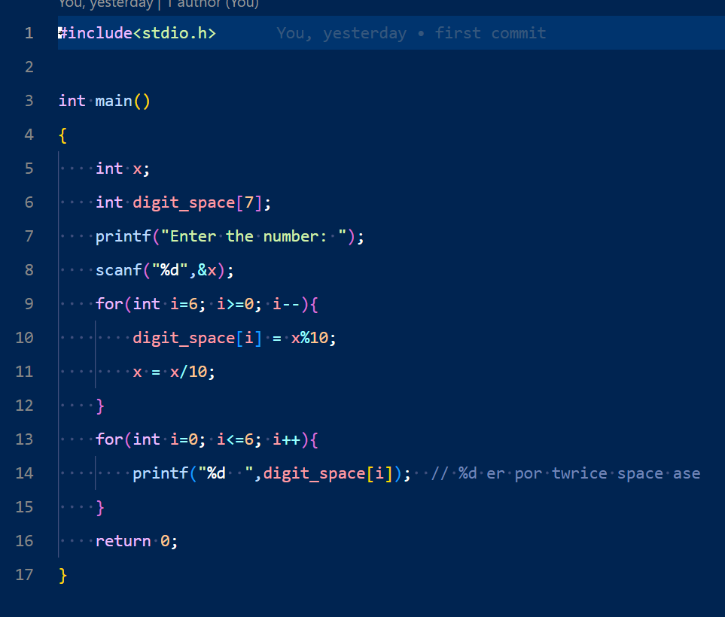

Output:



Problem No: 2302056_76

Problem Name: Write a C program to calculate and print the squares and cubes of the numbers from 0 to 20. It uses tabs to display them in a table of values.

Input:

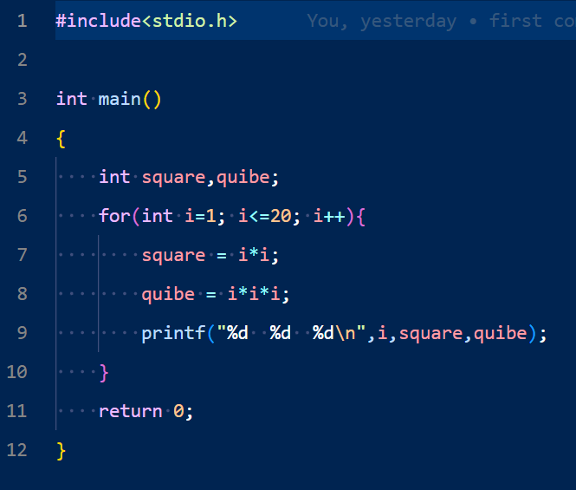

Output:

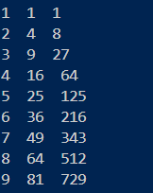

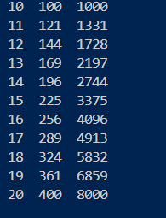

Problem No: 2302056_77

Problem Name: Write a C program that accepts principal amount, rate of interest and days for a loan and calculates the simple interest for the loan, using the following formula.

Input:

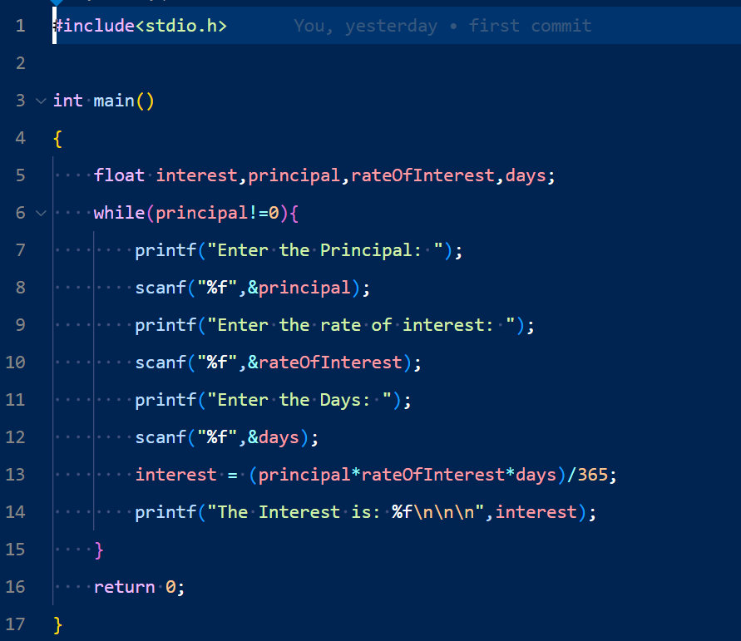

Output:

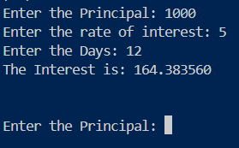

Problem No: 2302056_78

Problem Name: Write a C program to demonstrate the difference between predecrementing and postdecrementing using the decrement operator --.

Input:

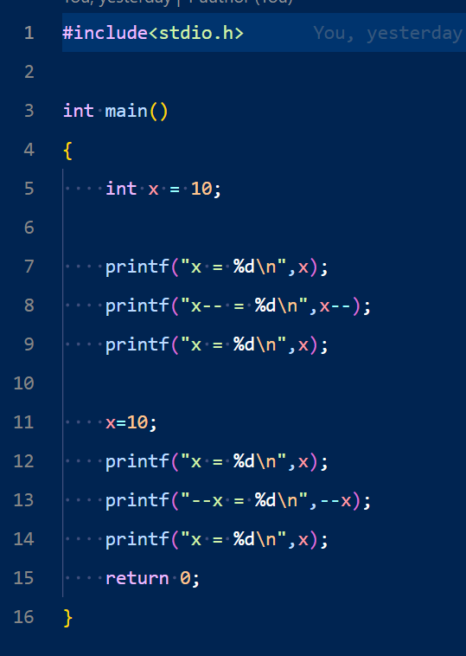

Output:

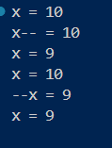

Problem No: 2302056_79

Problem Name: Write a C program using looping to produce the following table of values.

Input:

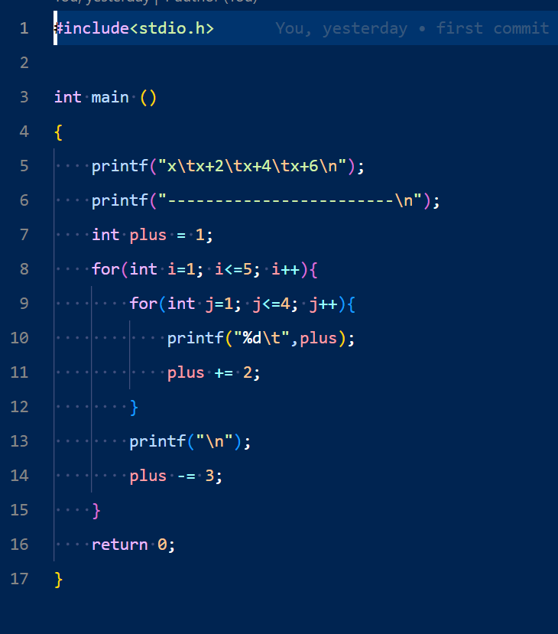

Output:

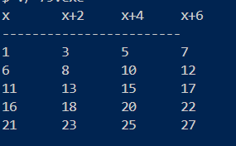

Problem No: 2302056_80

Problem Name: Write a C program that reads the side (side sizes between 1 and 10 ) of a square and prints square using hash (#) character.

Problem No: 2302056_80

Problem Name: Write a C program that reads the side (side sizes between 1 and 10 ) of a square and prints square using hash (#) character.

Inptut:

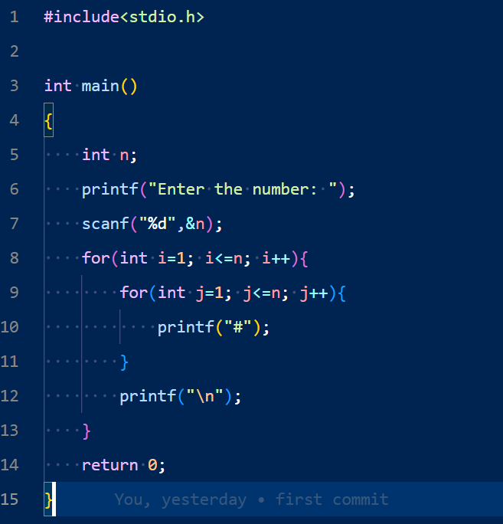

Output:

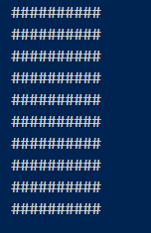

Problem No: 2302056_81

Problem Name: Write a C program that reads the side (side sizes between 1 and 10 ) of a square and prints a hollow square using the hash (#) character.

Input:

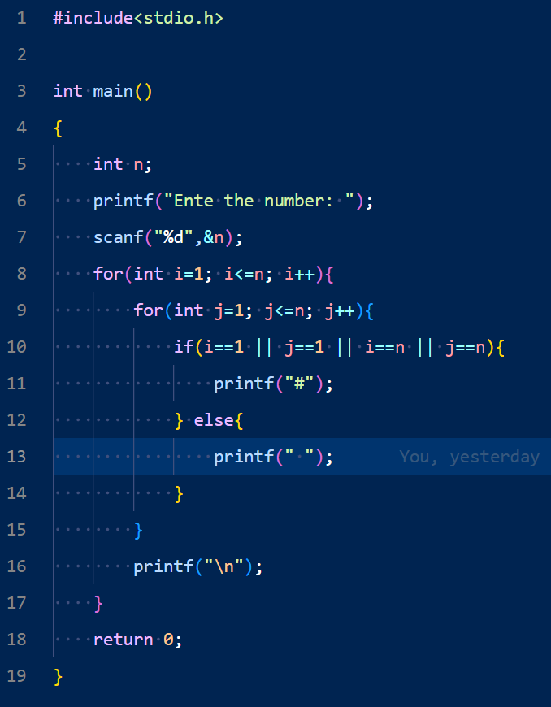

Output:

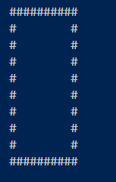

Problem No: 2302056_82

Problem Name: Write a C program that reads a five-digit integer and determines whether or not it's a palindrome.

Input:

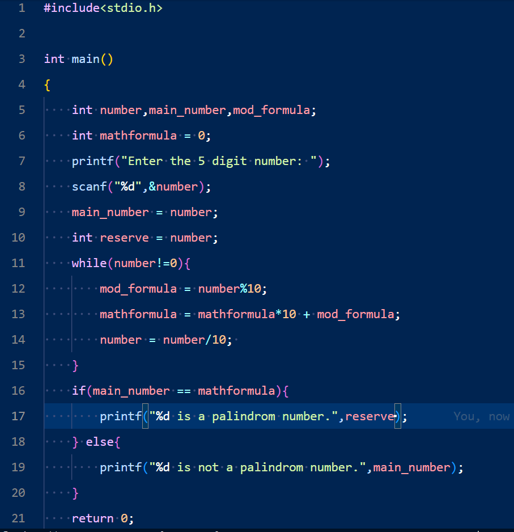

Output:



Problem No: 2302056_83

Problem Name: Write a C program that reads an integer (7 digits or fewer) and counts the number of 3s in the given number. Write a C program that reads an integer (7 digits or fewer) and counts the number of 3s in the given number.

Input:

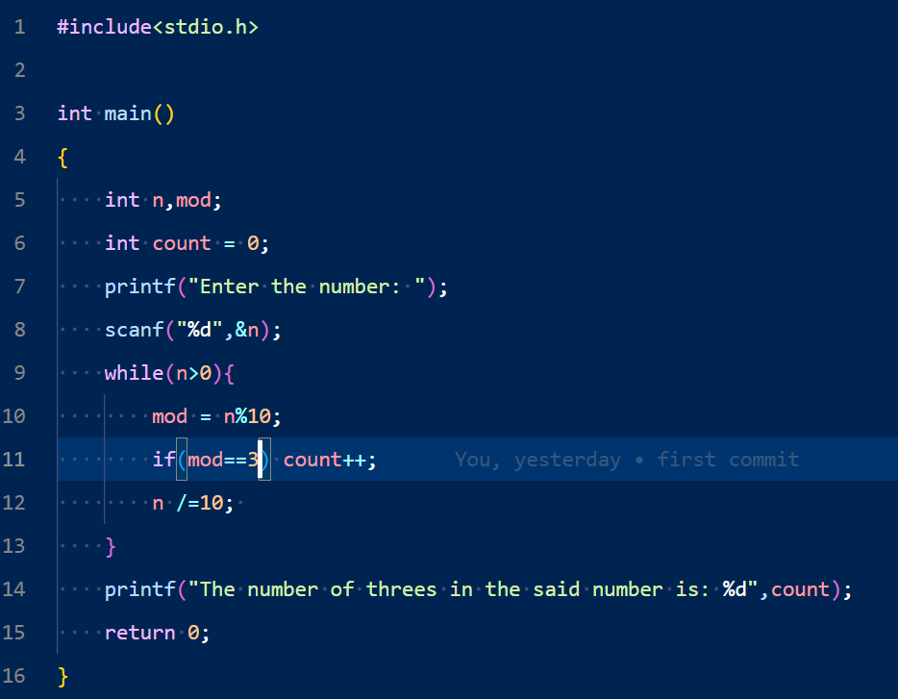

Output:



Problem No: 2302056_83

Problem Name: Write a C program to calculate and print the average of some integers. Accept all the values preceding 888.

Input:

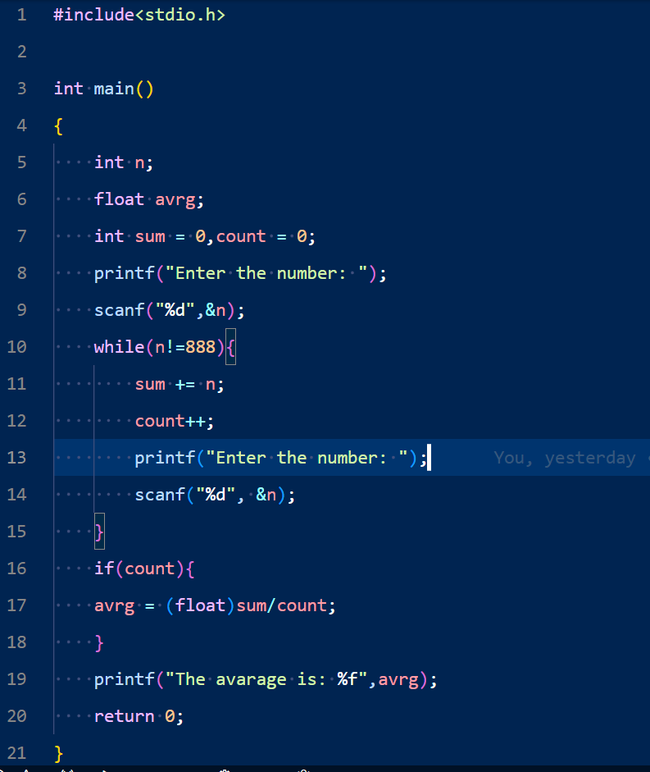

Output:

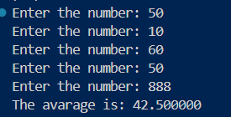

Problem No: 2302056_86

Problem Name: Write a C program to display the sizes and ranges for each of C's data types.

Input:

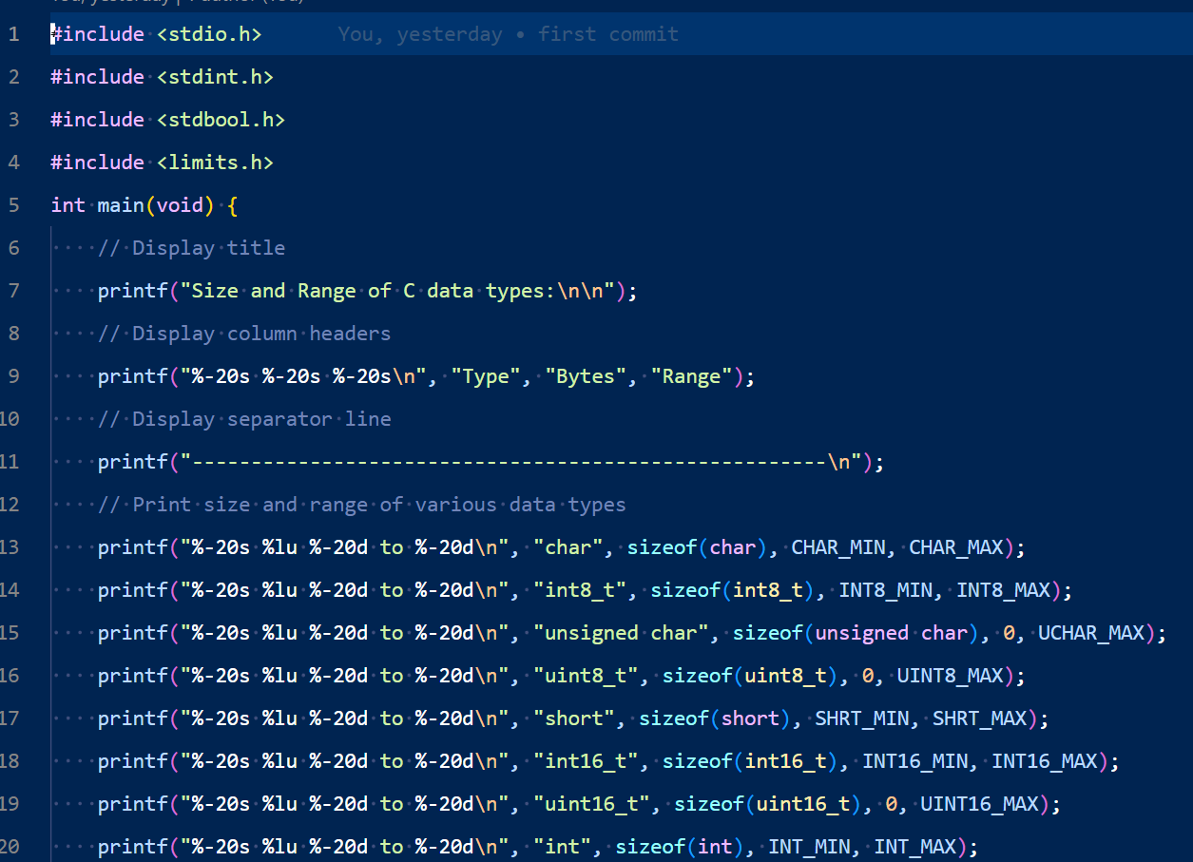

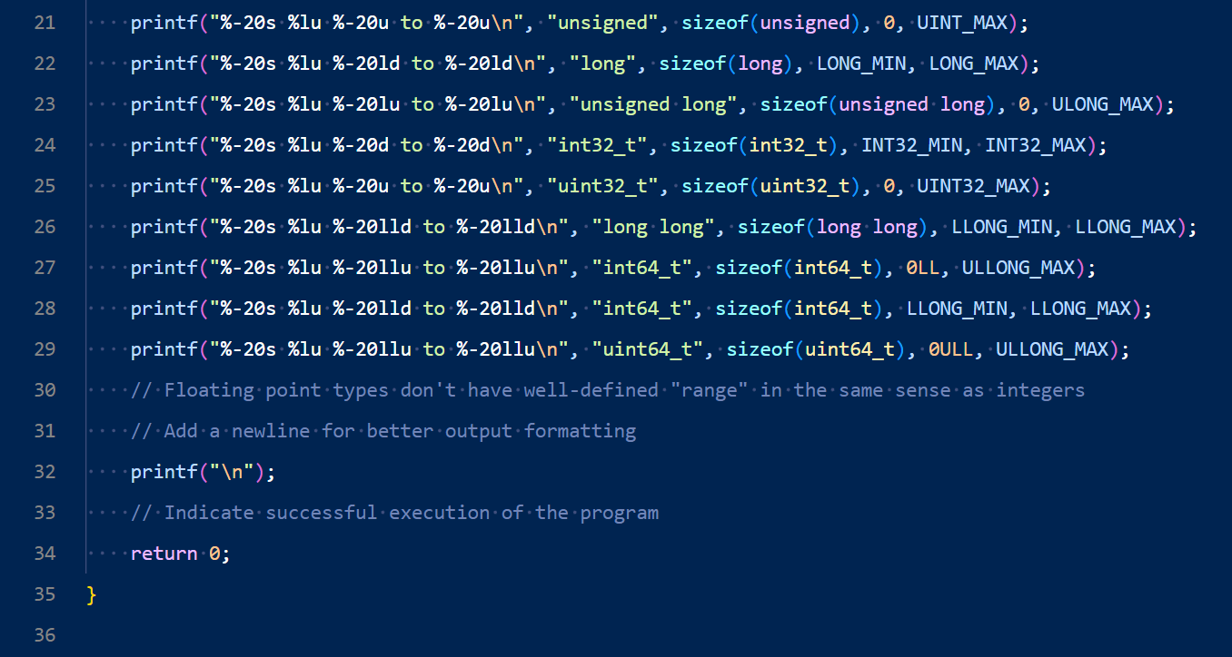

Output:

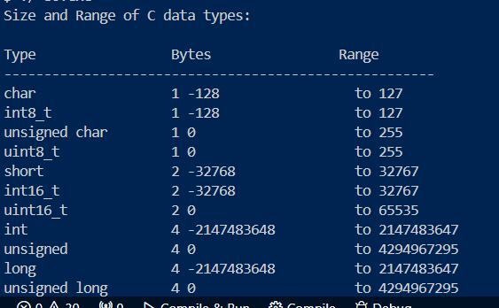

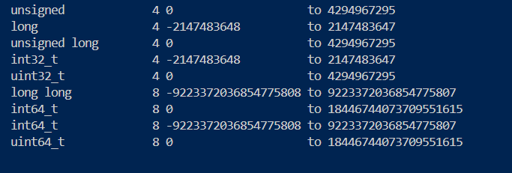

Problem No: 2302056_87

Problem Name: Write a C program to display the minimum and maximum values for each of C's data types.

Input:

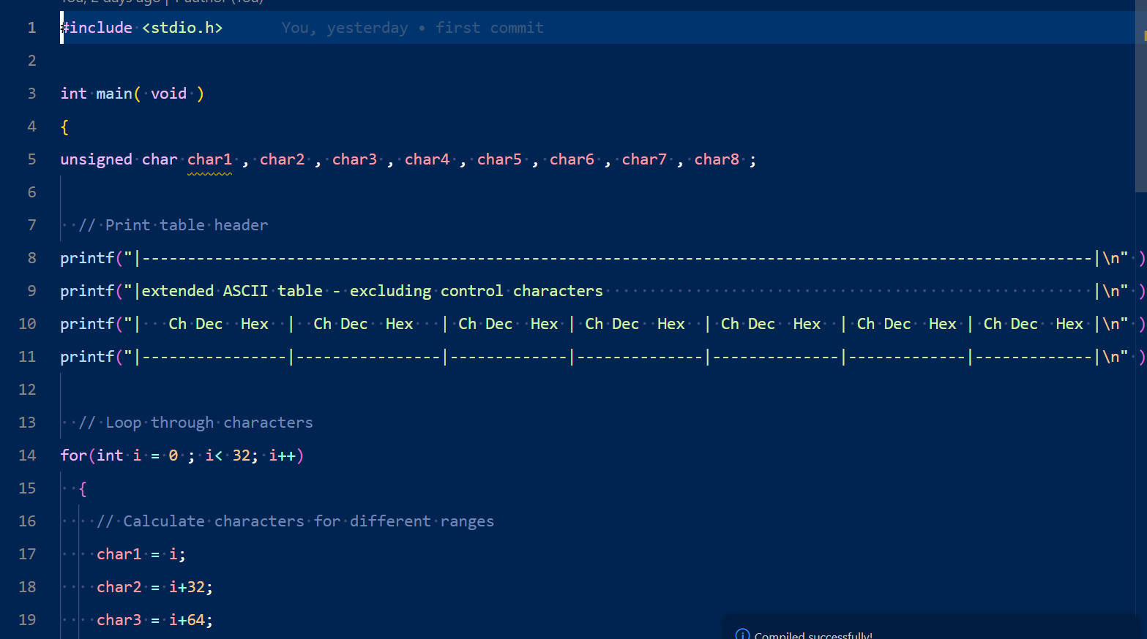

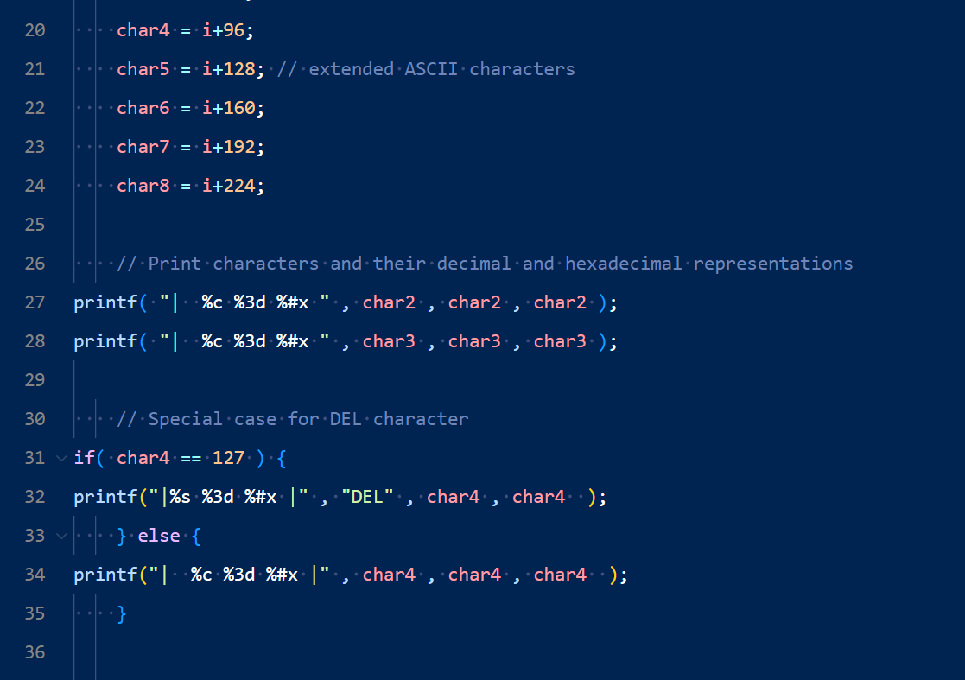

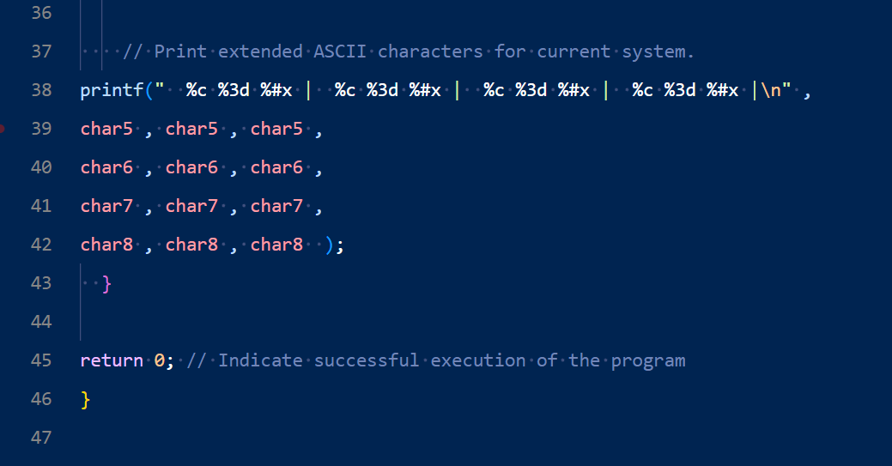

Ouptut:

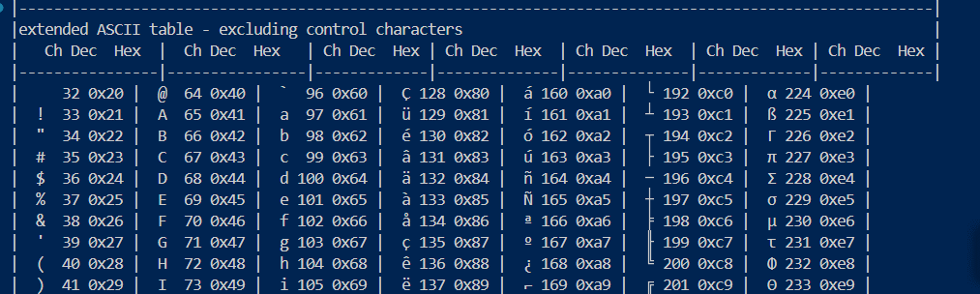

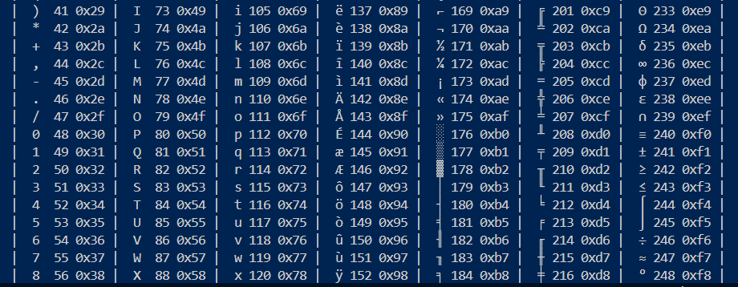

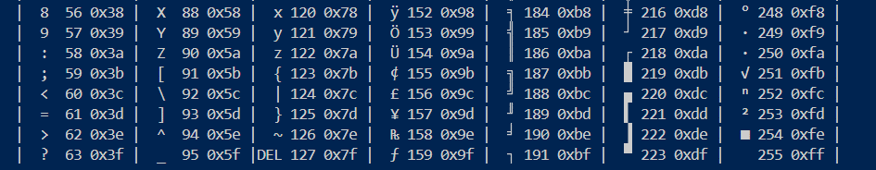

Problem No: 2302056_88

Write a C programming to calculate (x + y + z) for each pair of integers x, y and z where -2^31 <= x, y, z<= 2^31-1.

Input:

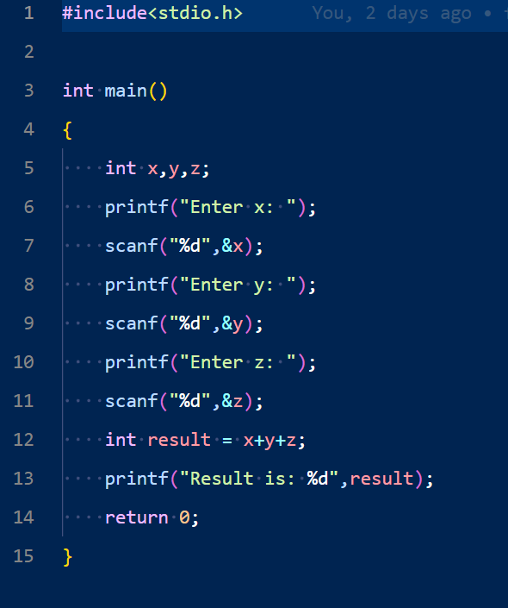

Output:

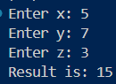

Problem No: 2302056_90

Problem Name: Write a C program to find all prime palindromes in the range of two given numbers x and y (5 <= x<y<= 1000,000,000).

Input:

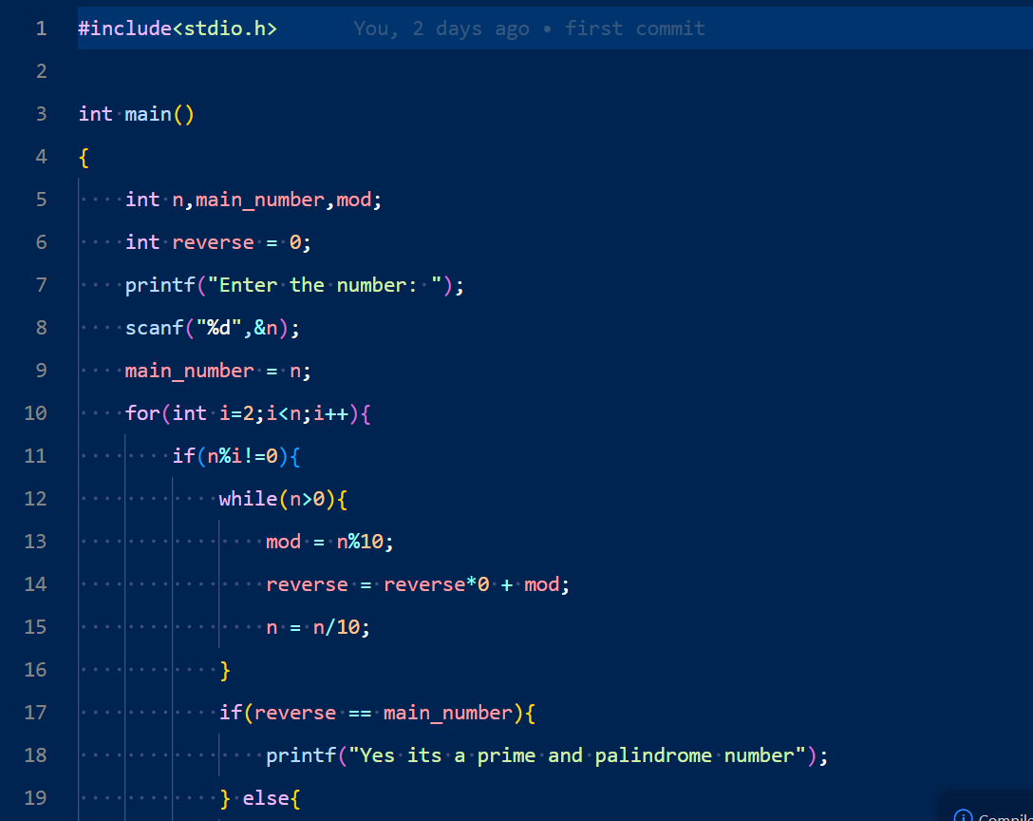

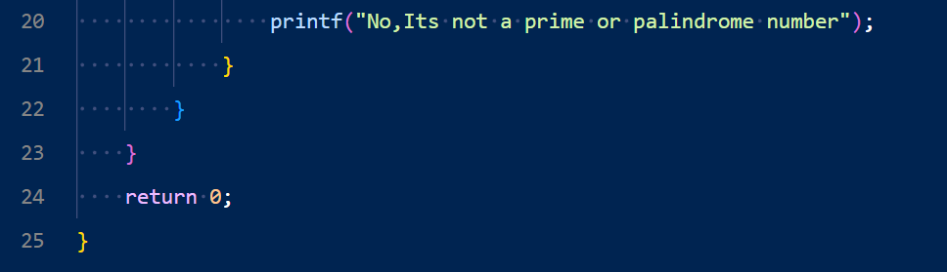

Output:

z 

Problem No: 2302056_91

Problem Name: Write a C program to find the angle between (12:00 to 11:59) the hour hand and the minute hand of a clock. The hour hand and the minute hand are always between 0 and 180 degrees.

Input: 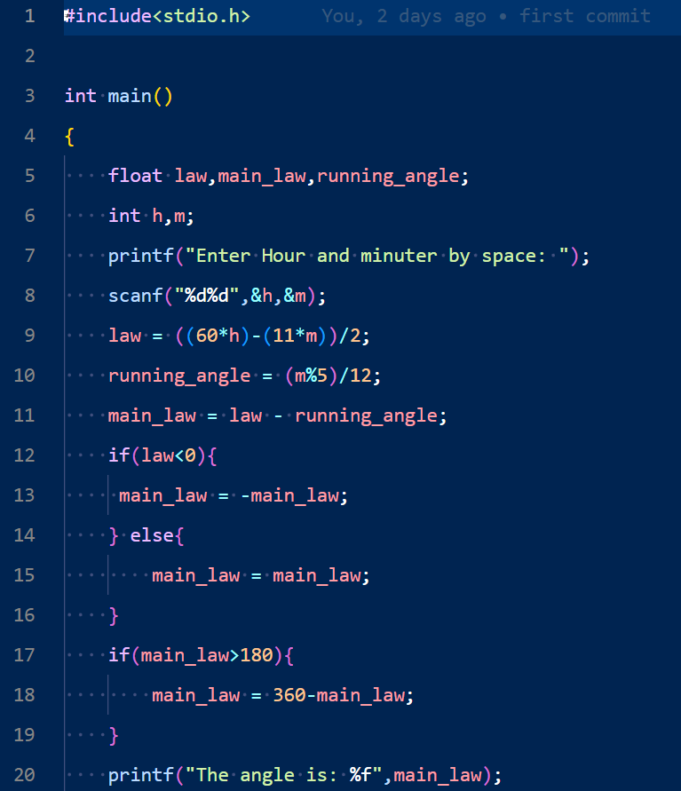



Output:

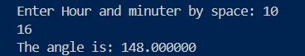

Problem No: 230056_92

Problem Name: Write a C program to find the last non-zero digit of the factorial of a given positive integer.

Input:

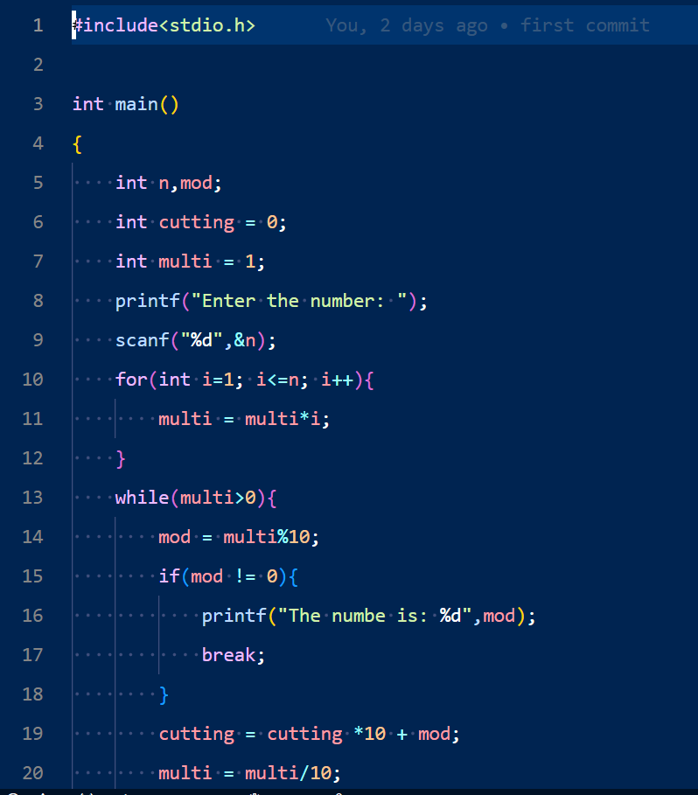 

Output:

 

Problem No: 2302056_94

Problem Name: Write a C program to calculate body mass index and display the grade.

Problem No: 2302056_95

Problem Name: Write a C program to print the corresponding Fahrenheit to Celsius and Celsius to Fahrenheit.

Input:

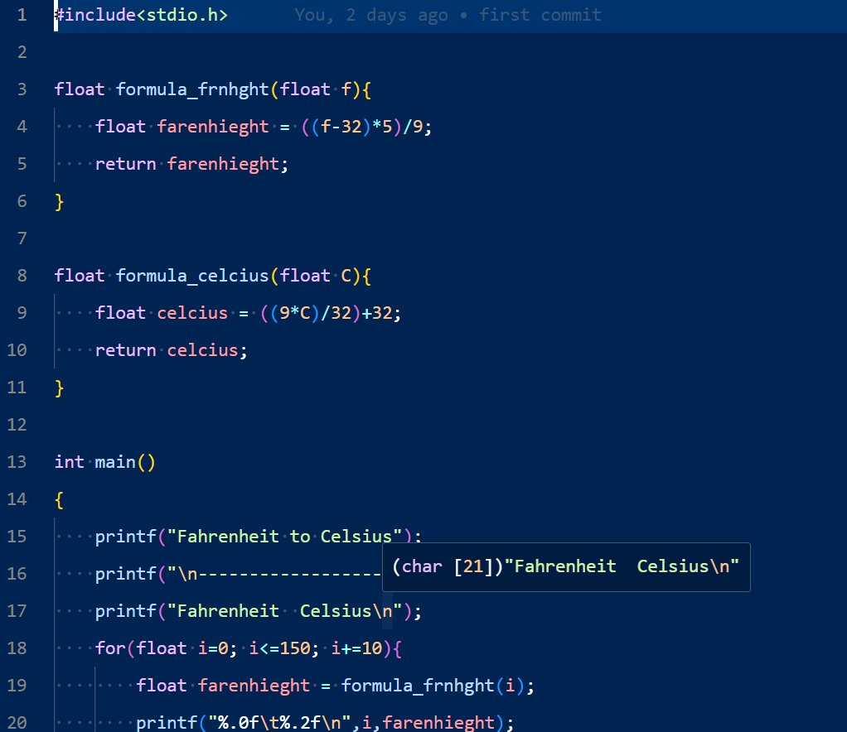

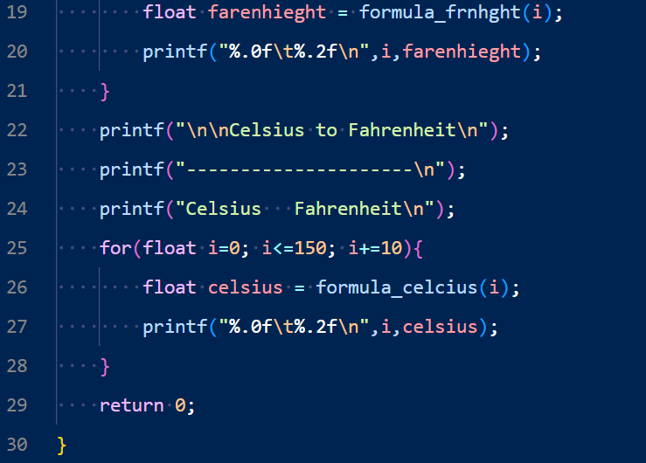

Output:

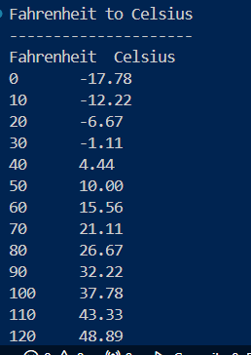

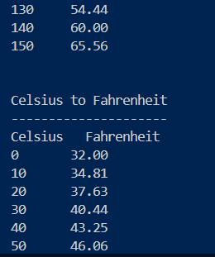

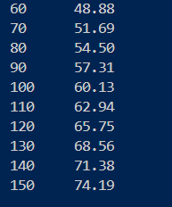

Problem No: 2302056_96

Problem Name: Write a C program to count blanks, tabs, and newlines in input text.

Input:

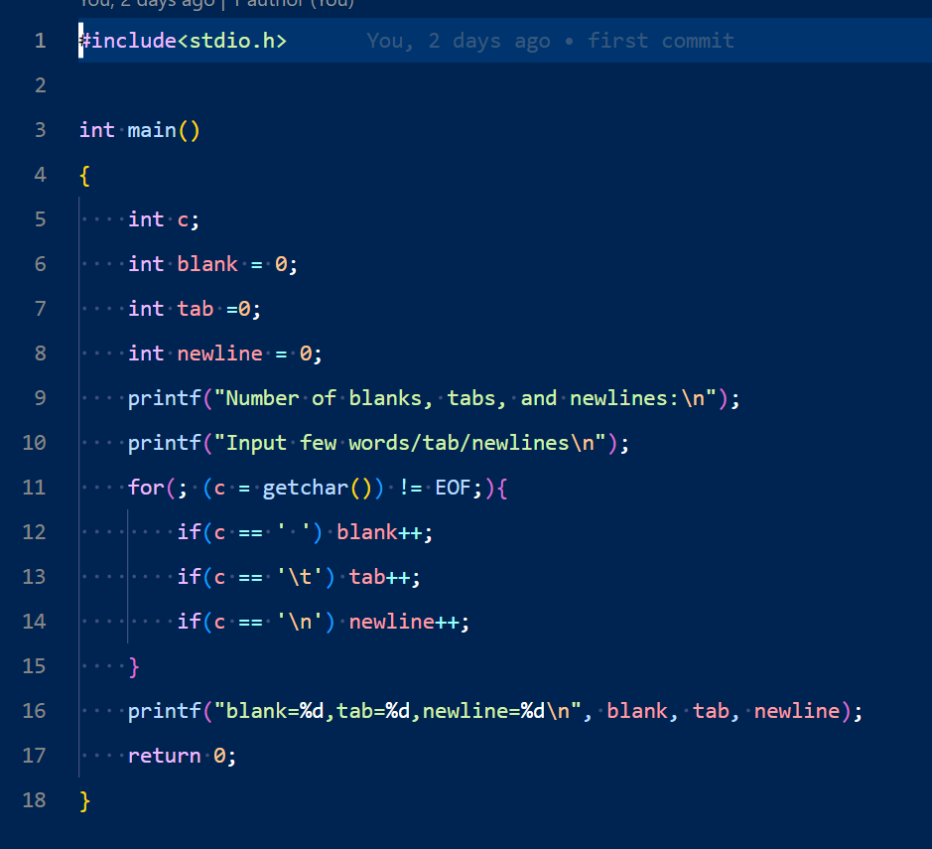 

Output:

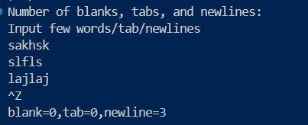

Problem No: 2302056_98

Problem Name: Write a C program that takes some integer values from the user and prints a histogram.

Input:

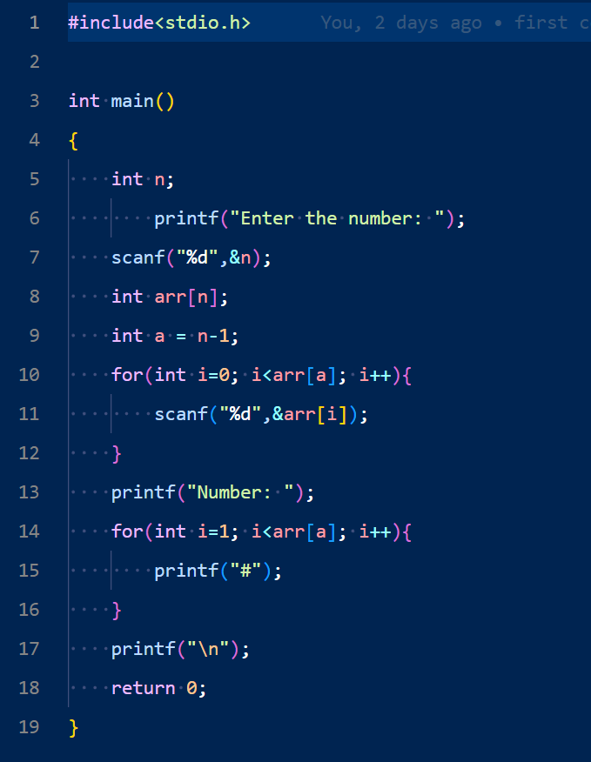

Outptut:

Problem No: 2302056_100

Problem Name: Write a C program to convert a currency value (floating point with two decimal places) to the number of coins and notes.

Input:

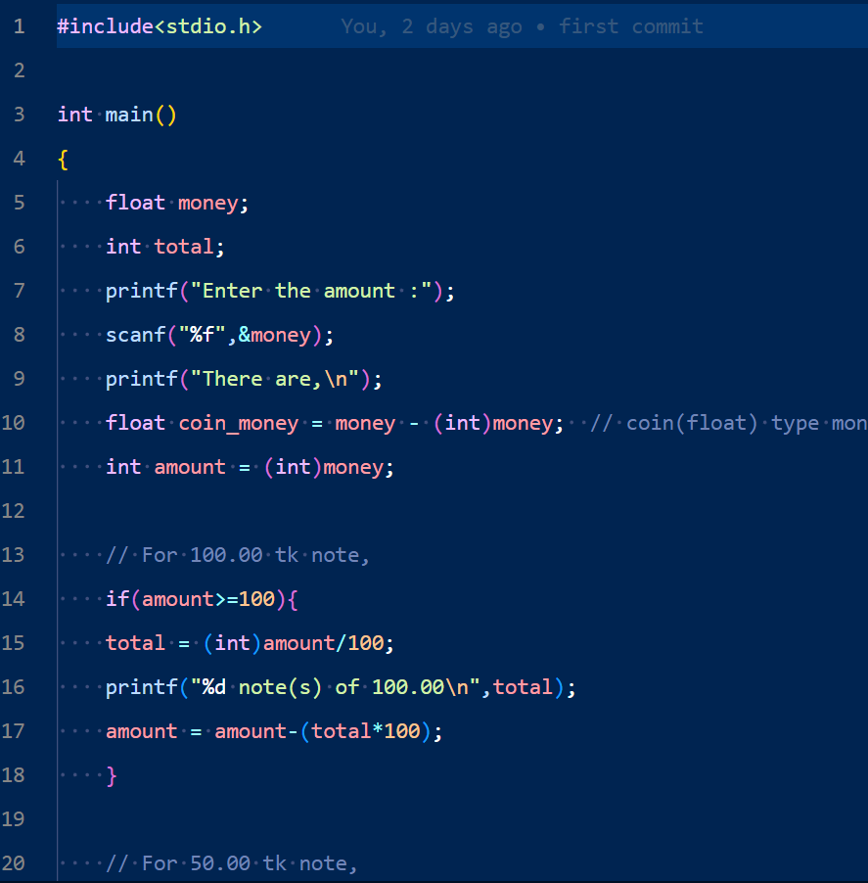 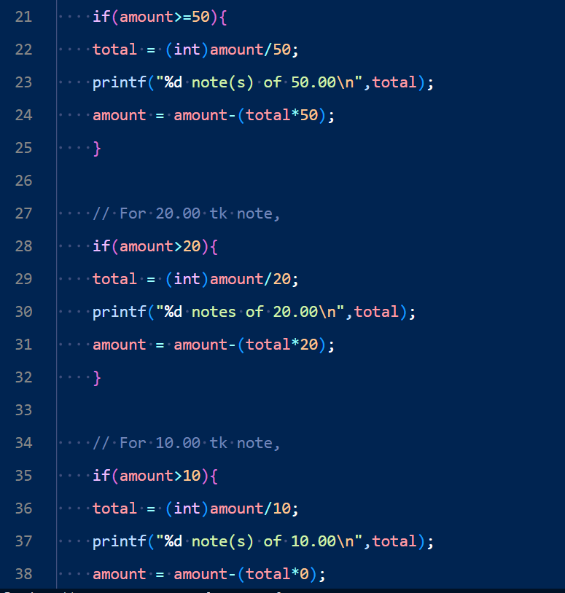 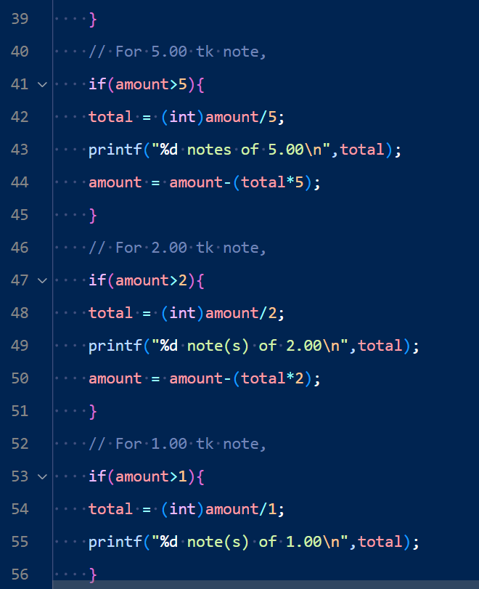 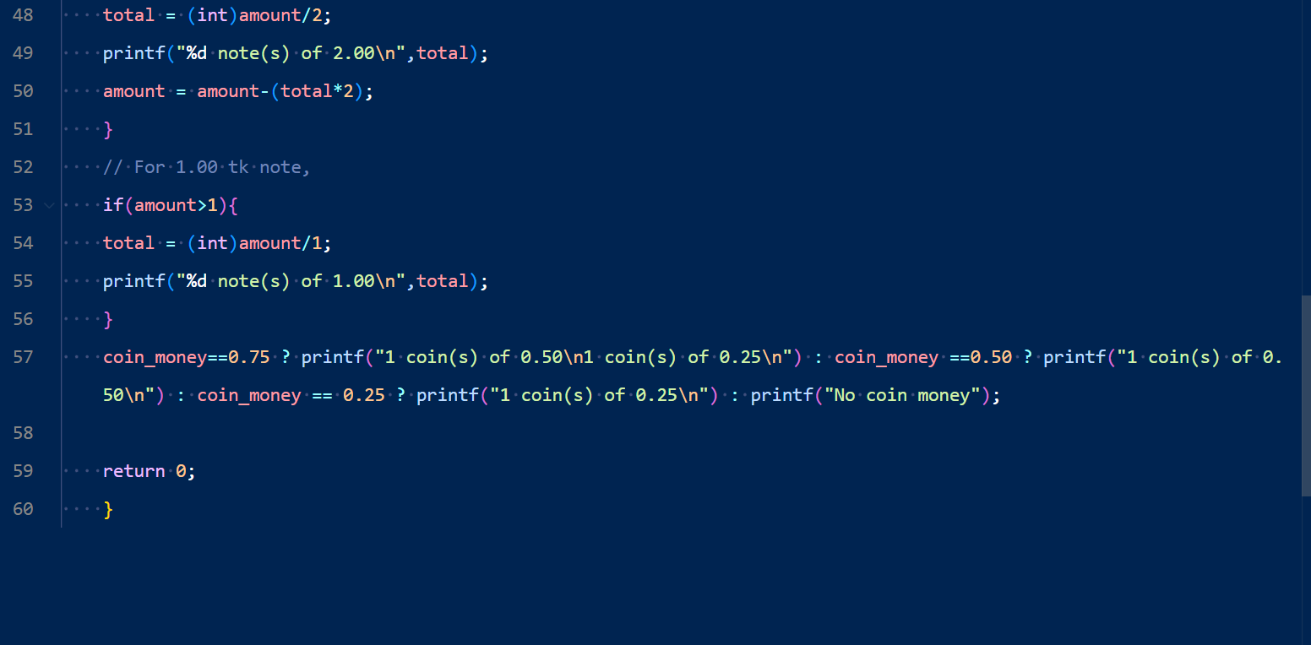

Output:

